[Date]

[NAME]
{Address]
{City, State, Zip]

Dear [First name]:

On behalf of the Jewish Community Relations Council of NY, our officers and your fellow Board members, we would like to express our gratitude for your most generous donation on [Payment Date] for the {Name of Campaign/Program] campaign.

Your support enables JCRC-NY to continue building vital bridges within the Jewish community and with New Yorkers of all backgrounds and faiths. In today’s complex and often challenging times, your gift strengthens our efforts to advance the values, interests, and security of the Jewish community and creates a more connected, inclusive, and resilient New York.

We are truly fortunate to have you on the Board and are indebted to you for your leadership, dedication and commitment. Your guidance and input on the important issues and initiatives in which we engage is always welcome, and it is our pleasure to have you as part of the JCRC-NY family!

Sincerely,

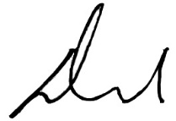 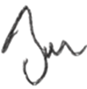 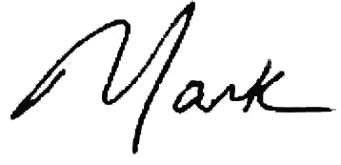
David L. Moore Bennett W. Golub Mark Treyger
President Chair of the Board CEO

